1. Agenda:
   1. What is the purpose of in-built functional interface Predicate provided by Java Team?
2. 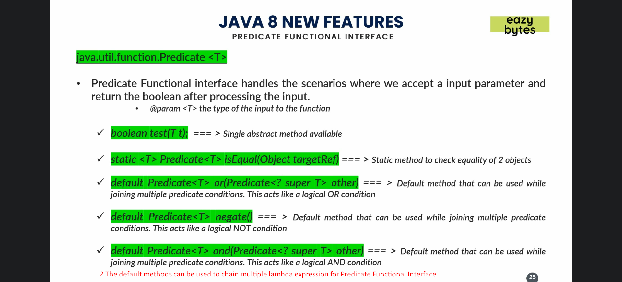
3. 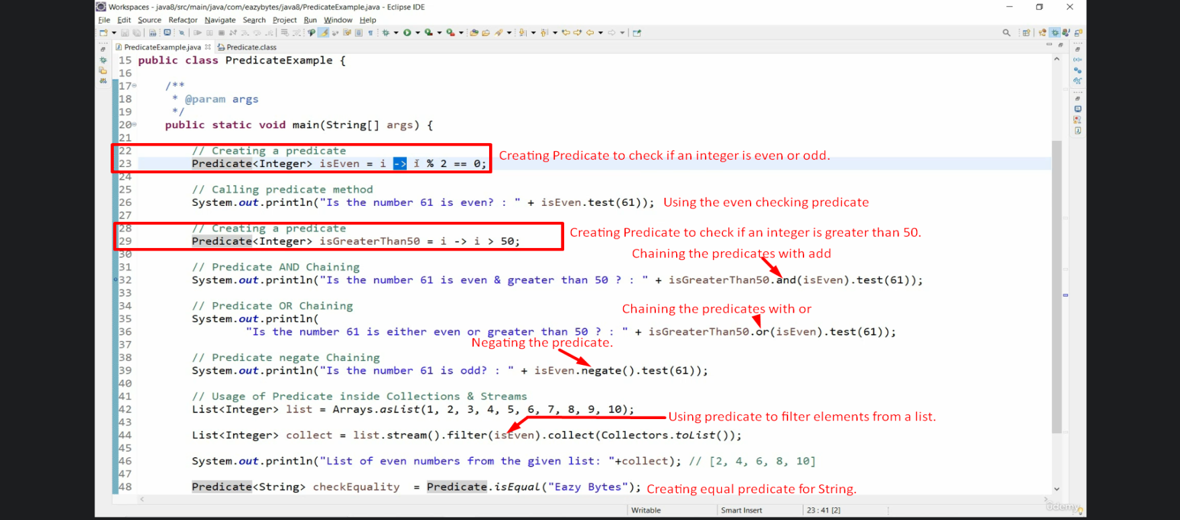 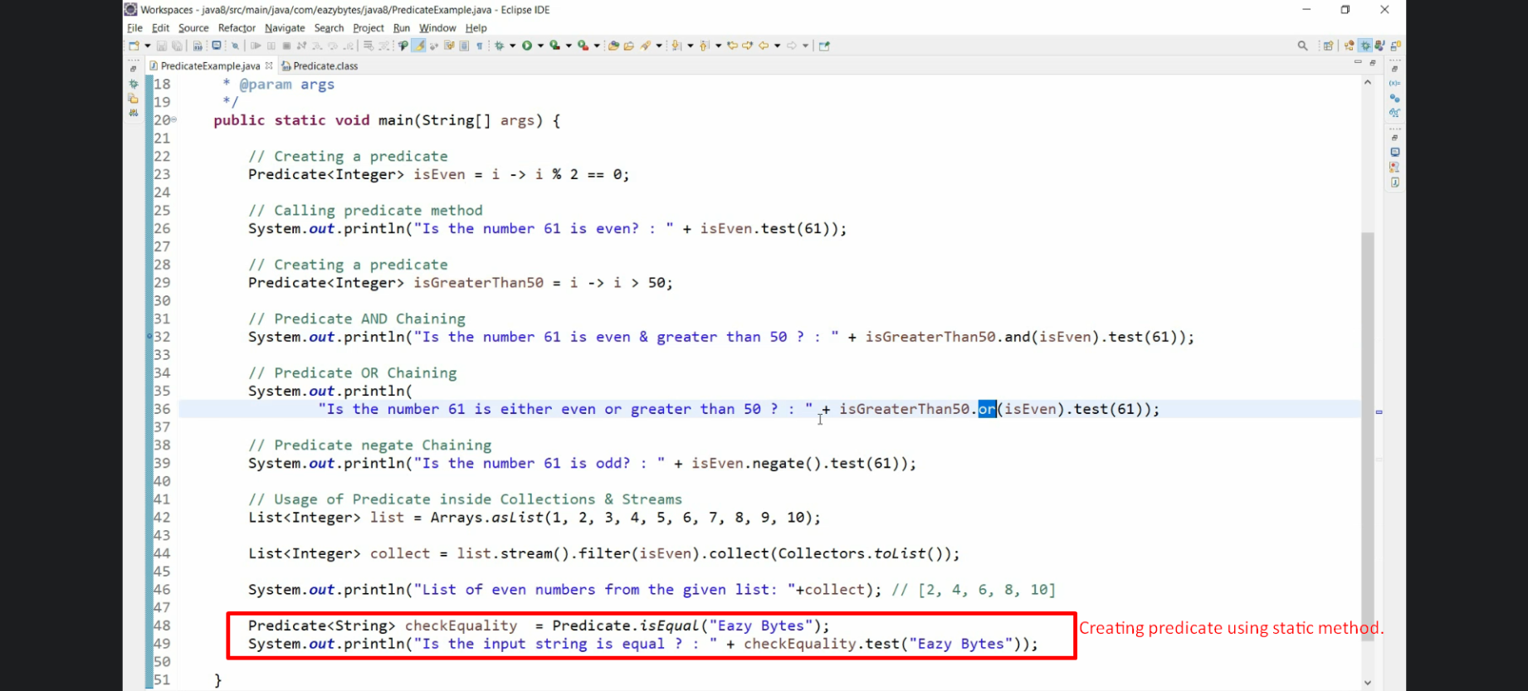
   1. Line#23: isEven holds the behaviour of validating a given input whether it is even or not and returns Boolean.
4. Predicate functional interface is used a lot inside stream API.
5. Write lambda expression without the need of unnecessary method, method name, if condition. They are not needed.
6. We can write different behaviours and can reuse them wherever we want as Line#24, 29.
7. Now in future if you need to take an object and based on some condition you want to return Boolean, think about Predicate.